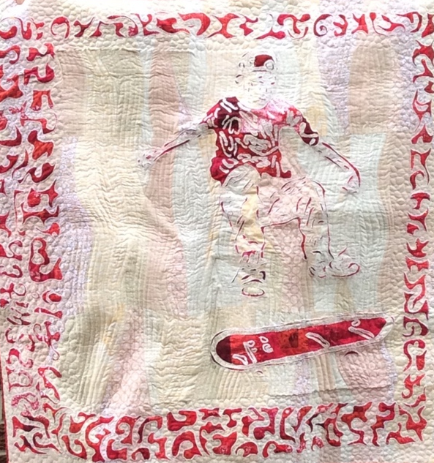
ThreadLICIOUS Trunk Show
By Janice Telfer
This will be a lively and interactive experience for the audience. In addition to quilts, dozens of story boards with real samples of threadpainting and observation bullet points will be discussed and distributed to the audience for up-close and detailed viewing.
ThreadLICIOUS will cover the story of, why, how and what I discovered when I developed techniques to do things differently. I will cover ‘light-bulb’ moments along my quilting journey when I discovered new ways, using unusual ‘tools’ to accomplish what I wanted to do. Quilts will be shown as they demonstrate some of the discovery and turning points of my quilting life.

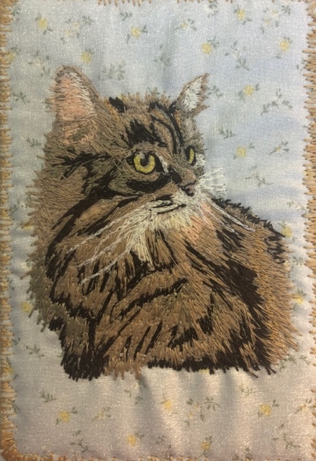
How often have you wondered ‘what if’ or ‘is there another way to accomplish this?’ The audience will have their curiosity re-awakened and will leave with techniques they can apply to their next quilting project. In addition, the audience will have a ‘hands-on’ opportunity to discover some magic techniques! Well, I thought it was magic when I discovered this….
Questions will be encouraged. They will drive discussions and examples will be viewed to illustrate points and responses.
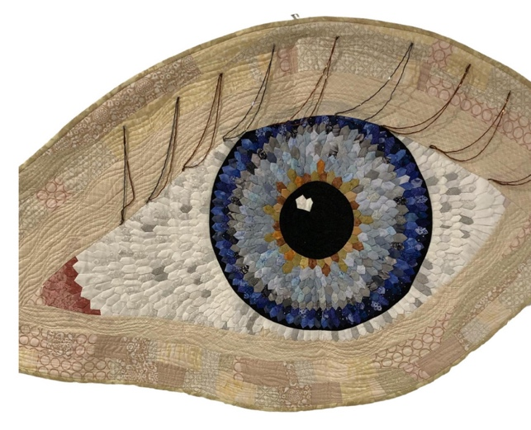

Bio – Janice Telfer
Janice likes to use scraps, break rules, explore techniques and add her own design touches to traditional patterns. She loves to think differently, share her passion for innovative processes and ideas, and to build community spirit while sewing with others.
As a result of a survey of quilters, Janice realized there was a niche waiting to be filled. Many didn’t want to buy more fabric, notions or tools to take a workshop. Some found full-day workshops too long. It was sometimes daunting to decide on what fabric to gather and prepare for workshops. Others didn’t want another WIP. BUT all were interested in continuous learning. They loved the opportunity to meet and socialize with others in a safe and supportive environment.
Make & Take mini workshops were born! All centred around a technique that was transferrable to other projects but would result in a finished mini project at the end of the workshop. Janice always provides kits, so participants just bring themselves and their sewing machines.

Janice has presented and taught in the UK, US, Quebec and around Ontario to many different groups.

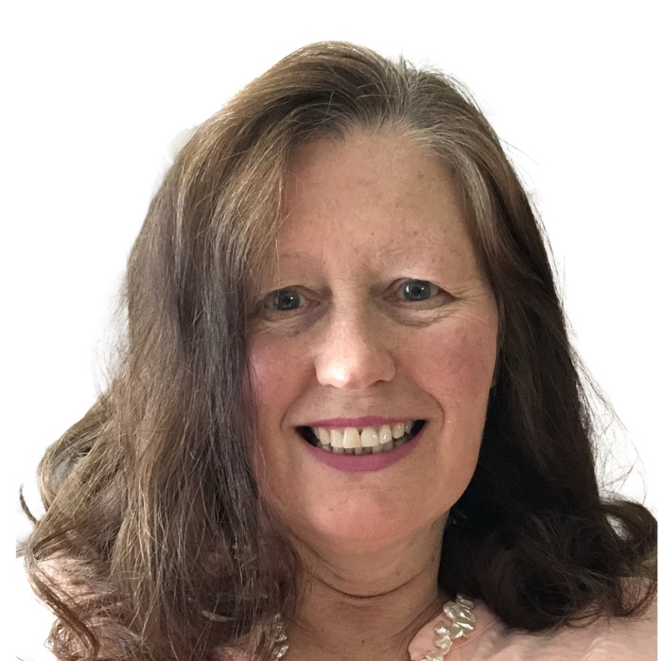
Janice’s quilts have been exhibited in Canada, the US and in Europe. She was an executive member of the Etobicoke Quilters’ Guild for seven years and a board member of another guild. Janice has helped quilting reach out into the broader community through a variety of new initiatives and events, aimed at the very young and all ages upwards.

