Grand Quilt Guild
Block of the Month
2021-22
Month | September 2021
Block | Nine Patch and Variations
Presented by | Lois MacPherson
Skills | Accurate cutting and sewing with 1/4 inch, colour composition, being creative outside the "block".

Notes and Pictures
Basic Nine Patch quilt block is made using 9 blocks of similar size and sewn together with 3 blocks in 3 rows.
A common variation of the Nine Patch Block is the Disappearing Nine Patch. This block is made starting with the Basic Nine Patch Block then slicing it across the centre vertically, then horizontally. These ¼ blocks can be rearranged in several different positions.
I suggest you turn to your computer and search. Word of caution: Remember your task is to make quilt block(s) not just watch the very entertaining videos. Search: “Quilt Nine Patch”
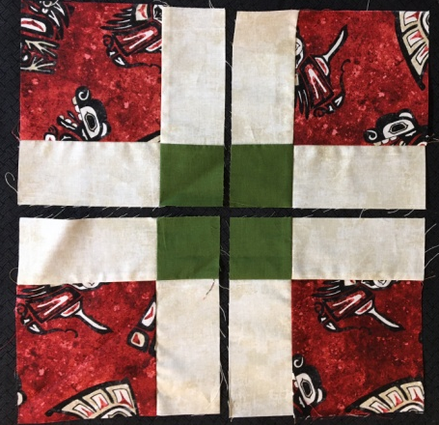
My basic nine patch before and after slicing.
Information regarding sizes:
Basic Nine patch: If squares are cut 4 ½” when sewn together will make a 12 ½” block that will finish at 12 Inches square.
When making a Disappearing Nine Patch with one horizontal and one vertical cuts are made:
- 4 ½ “ squares will equal a 12 “ block which will finishes at 11 ½ inches.
-5 “ squares will equal a 13 ½’ block which will finish at 13 inches.
-4 ¾” squares will equal a block that will finish at 12 ½”. ***

Here's a picture of my Disappearing Nine Patch quilt
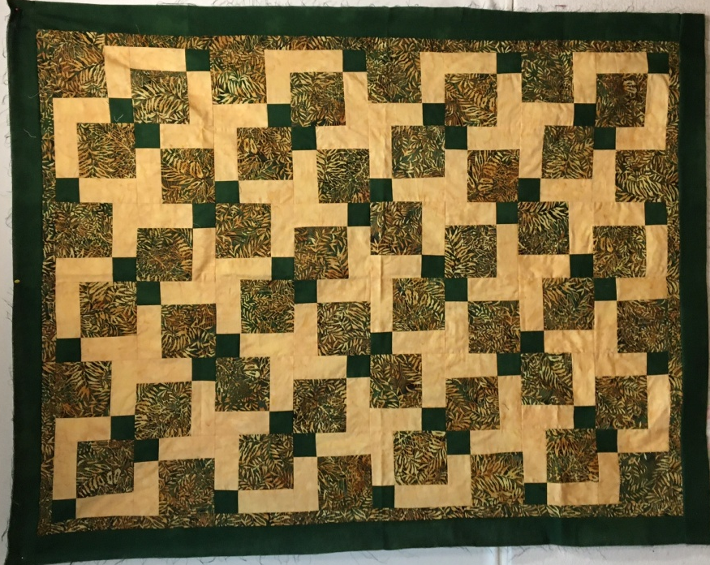

Challenge: The Nine Patch Block is the basis for many quilt patterns. For example the ‘Shoo Fly’ block is a nine patch with ½ square triangles in the corner. Below are some pictures of other projects which are basically Nine Patches.

Experienced quilters can you come up with some variations on the Nine Patch?
Pictures below of glorified 9 Patch and Moon Dance. These patterns came from workshops I attended in Arizona and I have no idea what some of the patterns are called.

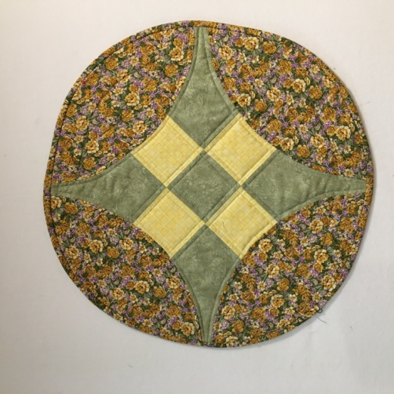

Resources
- Quilt in a Day Pattern # 1279, Moon Dance, designed by Sue Bouchard plus miscellaneous handouts from workshops I attended in the past.
- Quilt Block books
- You Tube
- The Missouri Quilt Company
- Pinterest
- Quilt Block Books and Magazines
- This presentation is on the website for future reference

Tips, Tools or Techniques
- Accurate cutting and accurate 1/4 inch seams
- Use of colour and contrast
- Accurate slicing of assembled pieces

